Aligning Volunteer Engagement to the Vision, Mission, and Strategic Plan of Your Organization
by Tessa Srebro posted on April 28, 2016
Posted in volunteer management
Guest post by Michael Fliess
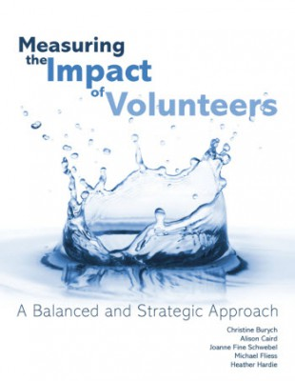Many leaders of volunteers agree that when volunteers are fully engaged, both the organization and the clients or cause they represent benefit.
Being “fully engaged” can mean different things to volunteers. However, in a 2013 recognition study conducted by Volunteer Canada, volunteers rated “wanting to know how their work has made an impact” as the most important way they could be recognized for their contribution.
How do leaders of volunteers ensure volunteers know their work has made a difference? As explained in the book,Measuring the Impact of Volunteers, co-authored by me, Christine Burych, Alison Caird, Joanne Fine Schwebel, and Heather Hardie, an important strategy to begin with is aligning volunteer roles with the vision, mission and strategic plan of the organization. When volunteers know their work is integral to the mission, they are more apt to feel truly part of the team, which builds a stronger commitment to your organization.
Six important steps to creating alignment include:
- Review the vision, mission, and strategic plan of your organization
Familiarize yourself with your organization’s strategic plan, mission, and vision to have a clear understanding of the goals and objectives. This will ensure that volunteers are integrated with that effort and not working at cross-purposes.
- Identify ways in which volunteer involvement supports your strategic plan
Start assessing whether volunteer contributions support your strategic plan by articulating all the volunteer work currently performed. You can apply a SWOT analysis (strengths, weaknesses, opportunities, threats) of volunteer engagement to the directives of the organization. What work helps support immediate goals or long-term vision? Are there tasks that don’t fit into your organization’s plan?
- Identify where you may have gaps in programming/ service
Often, the best ideas for improvement come from the end-users of a product or service. This can include staff, clients, families of clients, and volunteers. They will often see needs that are not being met. From this input, identify ways the right volunteer or volunteer initiatives might help.
- Create volunteer positions that fully align with the needs of programs, clients and the core services of the organization
The identification of gaps, weaknesses, and even strengths that could be expanded is where you will find ideas for new and high impact volunteer roles. Be sure to review any changes or new volunteer roles with the end-users of that role. For example, you may see a perfect opportunity for volunteers, but ensure that the team/ program with whom you would place new volunteers agree.
- Ask staff, clients and stakeholders to evaluate volunteer engagement
Don’t be afraid to receive and even facilitate feedback about volunteer efforts. This can be done through several different tools such as surveys, interviews, and focus groups. Ensure that you model an atmosphere of openness, where feedback and suggestions are welcomed as an opportunity for improvements.
- Measure and report on the impact of what volunteers do
Finally, demonstrate the impact of volunteer engagement. Show volunteers, staff, and organization leaders which accomplishments directly support the goals of the organization.
These six steps will ensure that volunteers are recruited and placed in truly strategic ways. Beginning with a focus on alignment with your organization’s vision sets the stage for leaders of volunteers to support the successful engagement of volunteers.
About the author:
Michael Fliess has worked in the field of volunteer management for over 18 years with a focus in the non-profit/healthcare sector. He has served in leadership roles with the Professional Association of Volunteer Leaders – Ontario (PAVRO), as a director at large, co-chair of the PAVR-O Mentor Program and Survey Lead for the Standardized Volunteer Opinion Survey. Michael is a co-author and project lead for Measuring the Impact of Volunteers: A Balanced and Strategic Approach, by ChristineBurych, Alison Caird, Joanne Fine Schwebel, Michael Fliess, and Heather Hardie (© 2016, Energize, Inc.)

